**Problem 1: Display the first and last 5 rows**

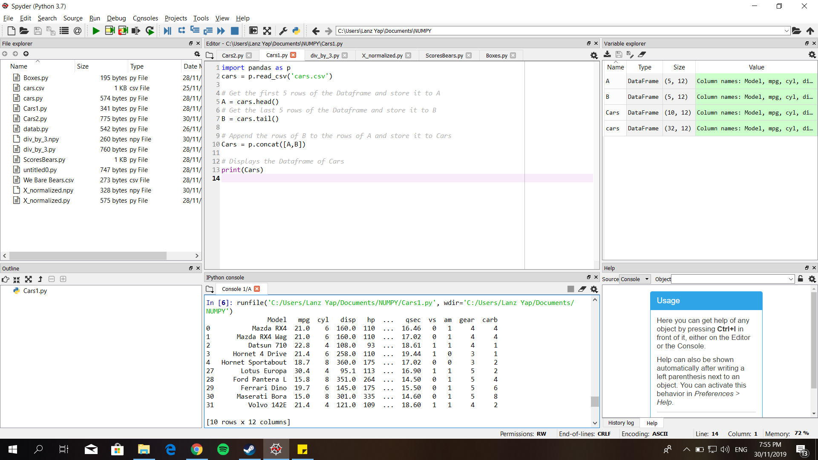

**Problem 2:**

1. **Display the first five rows with odd numbered columns**

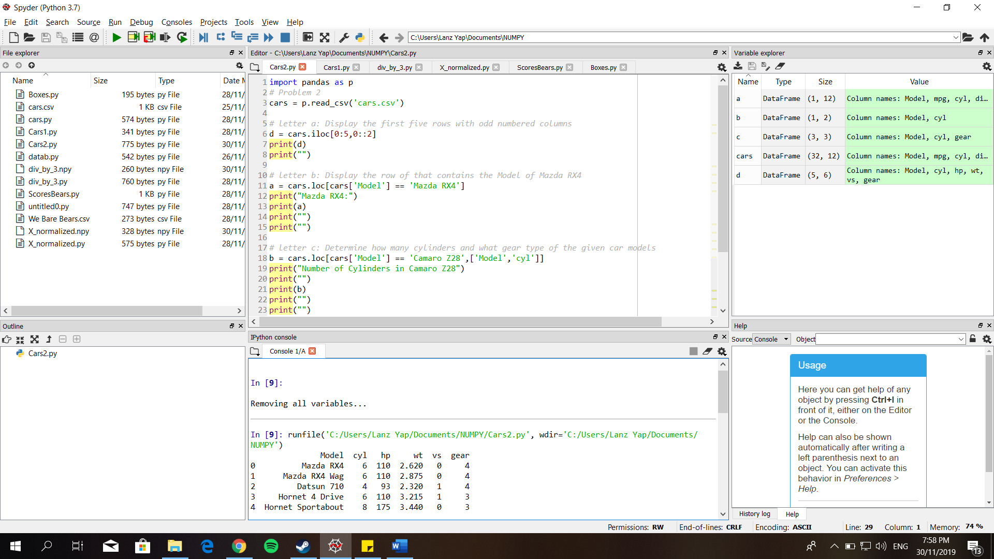

1. **Display the row of that contains the Model of Mazda RX4**

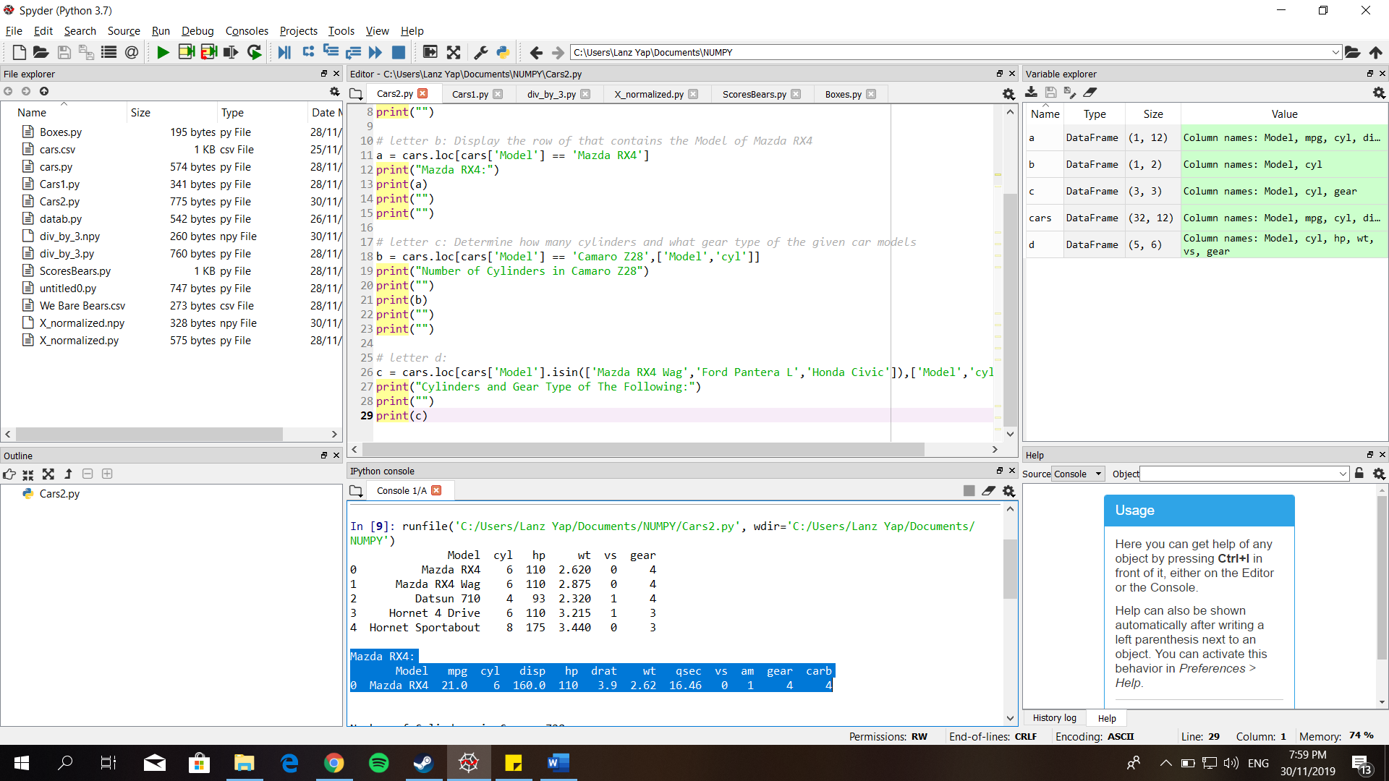

1. **Determine how many cylinders does the car model Camaro Z28 have**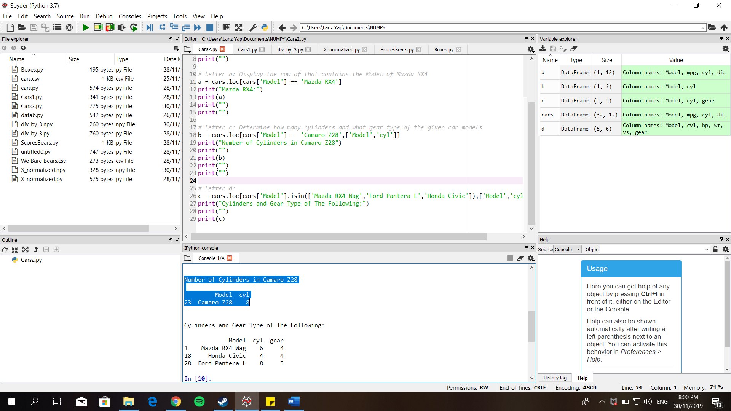
2. **Determine how many cylinders and what gear type of the given car models**

